



ML Ops & Containerization
LAB MANUAL

Disclaimer: The content is curated from online/offline resources and used for educational purpose only
Set up a basic CICD pipeline using GitHub Actions
Objective
To create a Continuous Integration and Continuous Deployment (CI/CD) pipeline using GitHub Actions to automate the testing and deployment of a Python-based Flask application that serves a trained Iris classifier model via a REST API.
Dataset
This lab uses the classic Iris flower dataset (Fisher, 1936) - 150 samples across 3 species (setosa, versicolor, virginica), described by 4 numeric features: sepal length, sepal width, petal length, and petal width. No separate file needs to be downloaded: scikit-learn ships this dataset built in, and train_model.py loads it directly via sklearn.datasets.load_iris().
Pre-requisites
- Basic knowledge of Python programming
- Familiarity with Git and GitHub for version control
- Understanding of machine learning concepts
- Familiarity with Flask
- Basic understanding of YAML syntax for configuring GitHub Actions workflows
- A GitHub account, and a basic understanding of HTTP requests (e.g. POST) and JSON
Requirements
- A computer with reliable internet access
- Python 3.12
- Git installed on your system
- A code editor such as Visual Studio Code
- Installed Python libraries: scikit-learn, flask, numpy, requests, joblib, pytest
- A GitHub repository to store the project code (created during the procedure)
- A Render account (free tier is sufficient) - sign up at https://render.com if you don't have one
- Download IRIS Dataset - https://archive.ics.uci.edu/dataset/53/iris

Procedure
Step 1: Set Up the Project Structure
mkdir iris-classifier-cicd
cd iris-classifier-cicd
git init

Create the following structure:
iris-classifier-cicd/
|-- app.py # Flask application to serve the API
|-- train_model.py # Script to train and save the model
|-- test_app.py # Unit tests for the API
|-- requirements.txt # List of Python dependencies
|-- .github/
| |-- workflows/
| |-- cicd.yml # CI/CD workflow configuration
|-- .gitignore

Create .gitignore with the following content:
__pycache__/
*.pyc
venv/
.env
*.pytest_cache/

Step 2: Train and Save the Iris Classifier Model
Create train_model.py:
import joblib
from sklearn.datasets import load_iris
from sklearn.model_selection import train_test_split
from sklearn.ensemble import RandomForestClassifier
from sklearn.metrics import accuracy_score

# 1. Load the Iris dataset
# scikit-learn ships this dataset built in, so no download or external file is required. It returns 150 samples, 4 numeric features, and 3 target classes (setosa, versicolor, virginica).
iris = load_iris()
X, y = iris.data, iris.target

# 2. Split into training and test sets
# stratify=y keeps the 3 species balanced between the two sets.
X_train, X_test, y_train, y_test = train_test_split(
X, y, test_size=0.2, random_state=42, stratify=y
)

# 3. Train a Random Forest classifier
model = RandomForestClassifier(n_estimators=100, random_state=42)
model.fit(X_train, y_train)

# 4. Evaluate on the held-out test set
accuracy = accuracy_score(y_test, model.predict(X_test))
print(f"Model trained. Test accuracy: {accuracy:.2f}")
# 5. Save the model together with its class names
# Saving target_names alongside the model means app.py can translate a numeric prediction (0/1/2) back into a species name ("setosa", "versicolor", "virginica") without having to hardcode that mapping separately and risk it drifting out of sync with the model.
joblib.dump(
{"model": model, "target_names": iris.target_names.tolist()},
"iris_model.pkl",
)
print("Model saved as iris_model.pkl")

Run the script:
python train_model.py

Add the generated model file to Git:
git add iris_model.pkl

Step 3: Create the Flask REST API
Create app.py:
import os
from flask import Flask, request, jsonify
import joblib
import numpy as np

app = Flask(__name__)

# Load the trained model and its class-name mapping once, when the process starts - not inside predict(), which would reload the file from disk on every single request.
saved = joblib.load("iris_model.pkl")
model = saved["model"]
target_names = saved["target_names"]

@app.route("/")
def home():
"""Simple health-check endpoint."""
return "Iris Classifier API is Running!"

@app.route("/predict", methods=["POST"])
def predict():
data = request.get_json(silent=True)

# Reject requests with no JSON body, or no "features" key, before touching the model.
if not data or "features" not in data:
return jsonify({"error": "Exactly 4 numerical features are required"}), 400

features = data["features"]

# The model was trained on exactly 4 numeric features (sepal length/width, petal length/width) - reject anything else with a clear message rather than letting the model raise a confusing internal error.
if not isinstance(features, list) or len(features) != 4:
return jsonify({"error": "Exactly 4 numerical features are required"}), 400

try:
features = [float(f) for f in features]
except (TypeError, ValueError):
return jsonify({"error": "Exactly 4 numerical features are required"}), 400

prediction_index = model.predict(np.array([features]))[0]
species = target_names[prediction_index]

return jsonify({"prediction": species})

if __name__ == "__main__":
# Render (and most cloud hosts) assign the port to listen on via the PORT environment variable at runtime; it is not fixed in advance. Falling back to 5000 keeps this working for local development too.
port = int(os.environ.get("PORT", 5000))
app.run(host="0.0.0.0", port=port)

Step 4: Create Unit Tests
Create test_app.py:
import pytest
from app import app

@pytest.fixture
def client():
app.config["TESTING"] = True
with app.test_client() as client:
yield client

def test_home_endpoint(client):
response = client.get("/")
assert response.status_code == 200
assert b"Iris Classifier API is Running!" in response.data

def test_valid_prediction(client):
response = client.post("/predict", json={"features": [5.1, 3.5, 1.4, 0.2]})
assert response.status_code == 200
data = response.get_json()
assert data["prediction"] == "setosa"

def test_invalid_input(client):
response = client.post("/predict", json={"features": [5.1, 3.5, 1.4]})
assert response.status_code == 400
data = response.get_json()
assert "error" in data

Run the tests:
pytest test_app.py

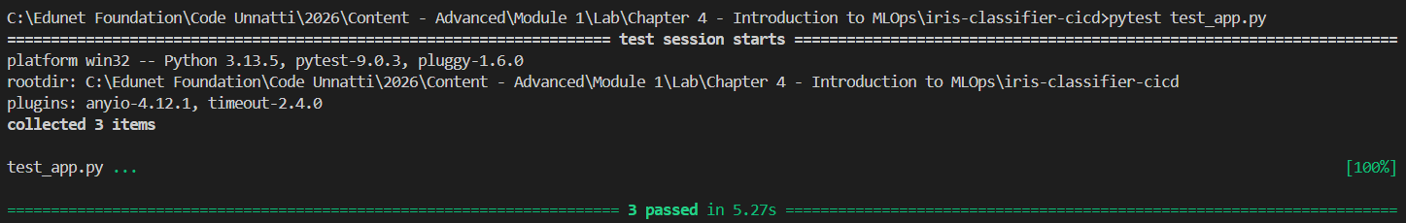
Step 5: Define Project Dependencies
Create requirements.txt, pinning exact versions for reproducibility:
flask==3.1.3
scikit-learn>=1.7
numpy>=2.2
joblib>=1.5
requests==2.32.3
pytest==8.2.2

Install locally:
pip install -r requirements.txt

Step 6: Set Up the GitHub Actions CI/CD Pipeline
If not created earlier - Create .github/workflows/cicd.yml:
name: CI/CD Pipeline

on:
push:
branches: [ main ]
pull_request:
branches: [ main ]

jobs:
test:
runs-on: ubuntu-latest
steps:
- name: Check out repository
uses: actions/checkout@v4

- name: Set up Python
uses: actions/setup-python@v5
with:
python-version: "3.12"

- name: Install dependencies
run: pip install -r requirements.txt

- name: Run tests
run: pytest test_app.py
deploy:
needs: test
if: github.ref == 'refs/heads/main' && github.event_name == 'push'
runs-on: ubuntu-latest
steps:
- name: Trigger Render deployment
env:
RENDER_API_KEY: ${{ secrets.RENDER_API_KEY }}
RENDER_SERVICE_ID: ${{ secrets.RENDER_SERVICE_ID }}
run: |
curl -X POST "https://api.render.com/v1/services/$RENDER_SERVICE_ID/deploys" \
-H "Authorization: Bearer $RENDER_API_KEY" \
-H "Content-Type: application/json"

Step 7: Push the Code to GitHub
Create a new, empty repository named iris-classifier-cicd on GitHub.com (do not initialize it with a README), then:
git add .
git commit -m "Initial commit with Iris classifier API and CI/CD pipeline"
git branch -M main
git remote add origin https://github.com/<your-username>/iris-classifier-cicd.git
git push -u origin main

Verify on GitHub.com that all files were uploaded.
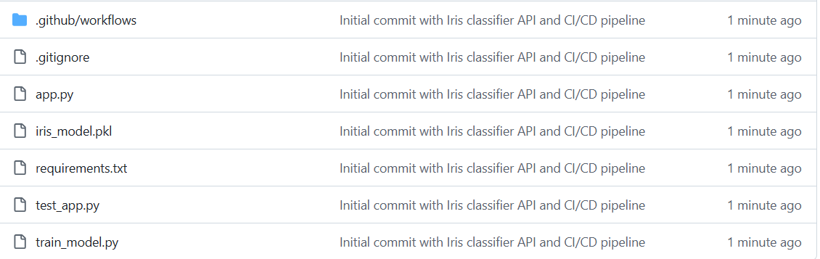

Step 8: Set Up Render for Deployment
Sign up or log in to Render using your GitHub account, then create a new Web Service and connect the iris-classifier-cicd repository. Configure it as follows:
Setting | Value
Name | iris-classifier-api
Branch | main
Root Directory | Leave blank
Runtime | Python
Build Command | pip install -r requirements.txt
Start Command | python app.py
Plan | Free tier

Click Create Web Service. Once deployed, note the public URL Render provides, e.g.:
https://iris-classifier-cicd-abqu.onrender.com
To let GitHub Actions trigger deployments itself (as configured in Step 6):
- In Render, go to Account Settings and generate an API key
- In the service's dashboard, find its Service ID (visible in the URL or settings)
In your GitHub repository, go to Settings > Secrets and variables > Actions, and add two repository secrets:
Secret name | Value
RENDER_API_KEY | Your Render API key
RENDER_SERVICE_ID | Your Render service ID

To test the pipeline, make a small change and push it:
git add app.py
git commit -m "Test CI/CD trigger"
git push

Then check the Actions tab in your GitHub repository to watch the workflow run the tests and, if they pass, trigger deployment.
Step 9: Test the Deployed API
Test the home endpoint by visiting the Render URL in a browser - it should display:
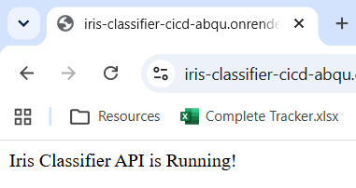
Test the prediction endpoint with curl:
curl -X POST https://iris-classifier-cicd-abqu.onrender.com/predict -H "Content-Type: application/json" -d "{\"features\":[5.1,3.5,1.4,0.2]}"

Expected output:
Conclusion
In this lab, a complete CI/CD pipeline was built for a machine learning API: a Random Forest classifier was trained on the classic Iris dataset and saved with joblib, a Flask REST API was built to serve predictions with input validation and clear error handling, pytest unit tests were written to check the home endpoint, a valid prediction, and an invalid request, and a GitHub Actions workflow was configured to run those tests on every push and trigger a Render deployment only when they pass.

